Atmospheric Chemistry
Option 1B

Atmosphere

Composition of atmosphere
The atmosphere is about 100km deep.

Constituents of air | Approx %
O₂  N₂  CO₂  Noble gases  Water  Pollutants | 21  78  0.03  1  Variable  Variable

Mixture because components can be separated by fractional distillation of liquid air. Air is filtered then compressed, cooled and released until temperature gets to
-200°C. It is then allowed to warm up gradually in fractionating column.

Oxygen (O₂)
Most reactive gas in air.
It was discovered by Joseph Priestly in 1778.
It reacts with most elements to form oxides.
It is a diatomic gaseous element and non-polar molecule.
Uses: Respiration, oxygen tents, steel making, combustion, oxyacetylene cutters, rocket fuel

Nitrogen (N₂)
Unreactive:
- Triple bond needs lots of energy to break
- Non-polar
- Colourless, odourless, tasteless

Uses:
- Food packaging
- Fills storage tanks in ships and factories to prevent explosions
- Making ammonia by Haber process
- Needed by plants to make proteins
- Liquid nitrogen freezes food, removes warts

Nitrogen fixation
Converting atmospheric nitrogen to compounds that can be used by plants

i) Lighting: The high temperature around the lightning bolt causes nitrogen to react with oxygen.

N₂ + O₂ = 2NO
2NO + O₂ = 2NO₂
2NO₂ + H₂O = HNO₂ + HNO₃

Nitric acid falls in rain and forms nitrates in soil

ii) Nitrogen fixing bacteria (rhizobium) in root nodules of leguminous plants

iii) Artificial fixation by Haber-Bosch Process

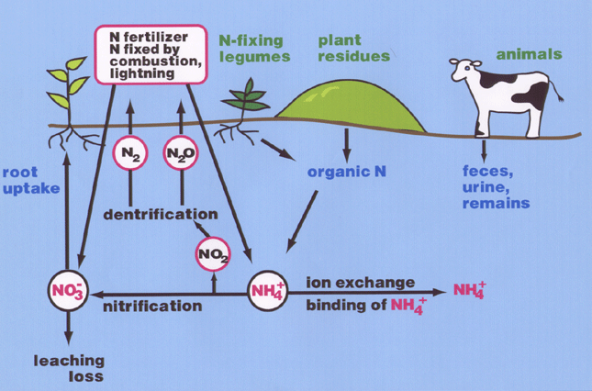

Inorganic carbon compounds

Carbon monoxide (CO)
- Formed by incomplete combustion in insufficient oxygen, e.g. smouldering fire, cigarettes and vehicle engines:
C + ¹/₂O₂ = CO
- Colourless, odourless and tasteless
- It is a cumulative poison, it binds to haemoglobin where oxygen should go and stays there stopping the haemoglobin working
- It is a neutral oxide
- Insoluble in water
- Does not react with acids or bases
- It has no effect on universal indicator or litmus

Carbon dioxide (CO₂)
Formed by:

(a) Combustion of carbon and fossil fuels
C + O₂ = CO₂
C₈H₁₈ + 12¹/₂O₂ = 8CO₂ + 9H₂O

(b) Respiration in both plant and animal cells
C₆H₁₂O₆ + 6O₂ = 6CO₂ + 6H₂O + ATP

(c) Fermentation of glucose by zymase from yeast in anaerobic conditions
C₆H₁₂O₆ = 2C₂H₅OH + 2CO₂

- It is an acidic oxide
- Soluble in water forming carbonic acid which turns universal indicator orange/yellow
CO₂ + H₂O = H₂CO₃

Carbonic acid dissociates in water to give both hydrogencarbonate (HCO₃⁻) and carbonate ions (CO₃²⁻)
H₂CO₃ = HCO₃⁻ + H⁺ = CO₃²⁻ + 2H⁺

Uses
- Photosynthesis
- Fizzy drinks - sharp taste of acid and fizz of gas coming out of solution)
- Fire extinguishers - heavier than air and does not support combustion
- Dry ice - solid CO₂ sublimes, forms stage mist with warm water

Universal Indicator

Universal indicator is a mixture of indicators that shows a wide range of colours depending on the pH of the solution.

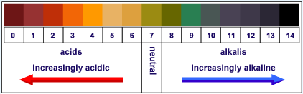

Effect of CO₂ on universal indicator

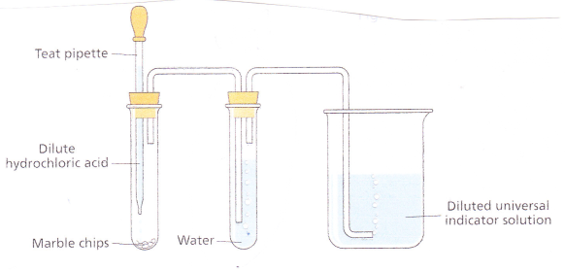
Method:
- Place 25cm₃ of universal indicator into a 100cm₃ beaker and dilute with equal volume of water.
- Place a few marble chips in a test tube and set up apparatus as shown.
- Add dilute HCl drop-wise.

Result:
As CO₂ gas is bubbled into a sample of universal indicator, the pH is gradually lowered as the amount of CO₂ increases and a series of colour changes is seen as the pH drops. Colour changes from green to red.

Carbon cycle

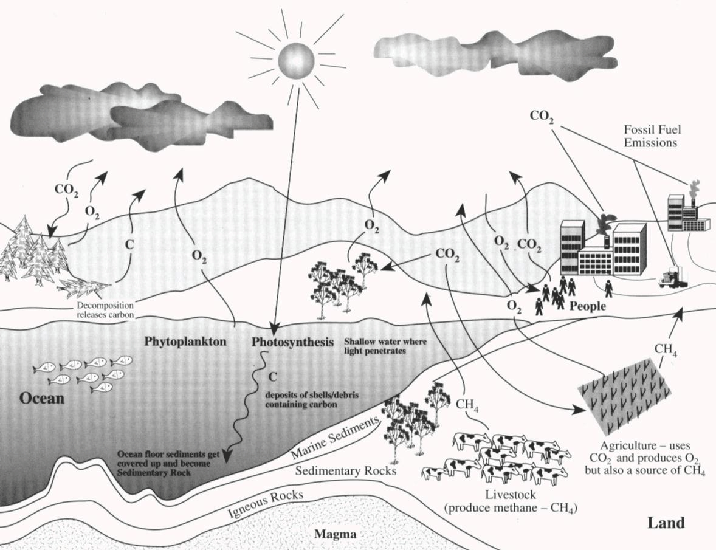

Noble gas uses
He - Super-cooling, filling airships, deep-sea divers “air” carrier for oxygen - less chance of “bends”
Ar - Filling light bulbs
Ne - Neon lights

Greenhouse effect

How it works
- Sun produces both long and short wave radiation
- Long wave bounces off the atmosphere
- Short wave passes through
- Short wave radiation absorbed by soil and plants
- Radiation is released again as long wave radiation
- Thus it gets trapped in atmosphere
- Energy of the atmosphere rises with the result that the temperature rises

Effects
- Essential for life on earth as it keeps earth warm enough for life to exist.
- The problem is the Enhanced Greenhouse Effect
- Results are more violent weather, melting ice-caps and raised sea levels etc.
- CO₂ from burning fossil fuels and CH₄ from rotting vegetation and ruminants are main causes
- CFCs and N₂O more effective at producing greenhouse effect but not as important
- Residence time is how long a gas stays in atmosphere.
CFCs and CO₂ = 100 years / CH₄ = 10 years
- CO₂ levels decreased by solution in the sea

Dissolving CO₂ in oceans
- At the surface of the oceans, air is constantly coming into contact with the water. Some of the carbon dioxide that dissolves in the water is changed into hydrogencarbonates and carbonates.
- Some of it is used up in photosynthesis by phytoplankton, while some is dispersed to deeper regions by ocean currents where the low temperatures ensure that it remains dissolved.
- These interaction of atmospheric carbon dioxide with the oceans is a significant factor in limiting the greenhouse effect

Contribution of the main greenhouse gases to Global Warming
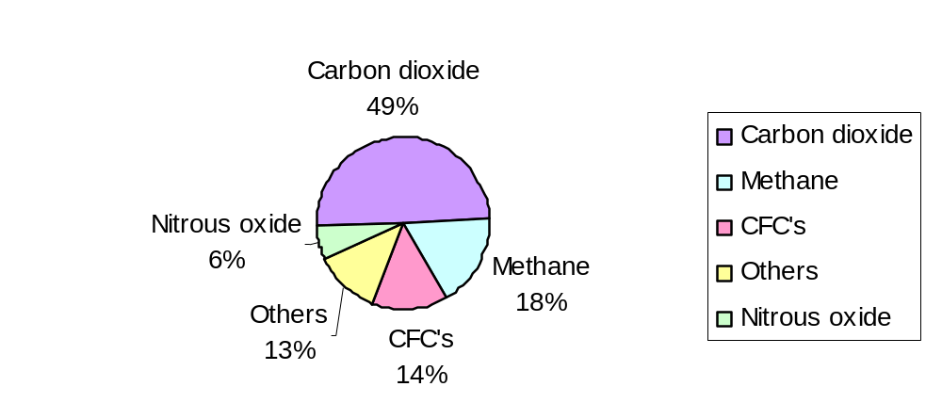

Greenhouse Factor
Greenhouse Factor is a measure of the greenhouse effect caused by a gas relative to the same amount of CO2, which is assigned a greenhouse factor of 1.

Gas | Greenhouse factor
Water vapour | 0.1
Carbon dioxide | 1
Methane | 30
Nitrous oxide | 160
CFC’s | 21,000 – 25,000

Methods of control
- Reduce, Re-use, Recycle – so less landfill sites
- Use renewable forms of energy such as wind, water and solar power – so less fossil fuels burnt
- Reforestation – plant more trees which act as sinks for CO2
- Replacements for CFC’s
- Dissolving CO2 in oceans

- Residence time is ‘rate of turnover of CO2 in the atmosphere’. Residence time for CO2 is ~ 100years.

Effect of SO₂ on universal indicator

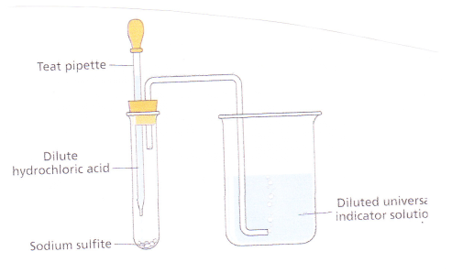
Method:
- Place 25cm₃ of universal indicator into a 100cm₃ beaker and dilute with equal volume of water.
- Place a spatula full of sodium sulphite in a test tube and set up apparatus as shown.
- Add dilute HCl drop-wise.

Result:
As SO₂ gas is bubbled into a sample of universal indicator, the pH is gradually lowered as the amount of SO₂ increases and a series of colour changes is seen as the pH drops. Colour changes from green to red.

Atmospheric pollution

Situation that exists when a constituent in the air is present to the extent that there is a significant risk to:-
(a) present health (b) future health (c) the environment.

Pollution is the addition of any damaging substance to the environment

Acid rain and its causes
Rainwater normally contains CO₂ dissolved in it and is slightly acidic: it is NOT acid rain.
Acid rain has a pH of less than 4.5

Sulphur dioxide (SO₂)
Sources: Volcanoes, fossil fuel combustion (about 85%) and industry
Formation: S_{(s)} + O_{2(g)} = SO_{2(g)}
SO_{2(g)} + H₂O_{(l)} = H₂SO_{3(aq)} [sulphurous acid]
H₂SO_{3(aq)} + ¹/₂O_{2(g)} = H₂SO_{4(aq)} [sulphuric acid]

Nitrogen dioxide (NO₂)
Sources: N₂ is unreactive and a high temperature is needed to make it react
e.g. car engines, industrial furnaces and lightning
Formation: N_{2(g)} + O_{2(g)} = 2NO_{(g)} [nitrogen monoxide - colourless]
NO_{(g)} + ¹/₂O_{2(g)} = NO_{2(g)} [nitrogen dioxide - brown gas]
2NO_{2(g)} + H₂O_{(l)} = HNO_{2(aq)} + HNO_{3(aq)}

Environmental effects of acid rain
- Corrosion - particularly of limestone, marble and metal
- Health effects: eyes and lungs damaged - most important in sick and elderly
- Death of plants: trees in Black Forest by SO₂ exported from GB
- Leaching of metals: e.g. Al which can cause poisoning - Alzheimer’s disease
- Death of animals: fish fry and eggs are very sensitive to pH - salmon almost wiped out in Scandinavia

Scrubbing of waste gases with limestone
Limestone can be used in power stations to remove SO₂ from chimney gases. This is called scrubbing:
CaCO₃ + SO₂ = CaSO₃ + CO₂

Ozone layer

- Ozone has the molecular formula O₃
- UV radiation causes sunburn and ultimately skin cancer
- Ozone screens us from the harmful effect of UV radiation by absorbing the UV.
- It is a pale blue gas, which condenses to a deep blue liquid.
- It’s also possible to get a sharp smell of ozone near photocopiers, where electricity passes through the air.
- In the lower atmosphere it can be detrimental to health aggravating asthma and bronchitis.
It was thought that there was a constant amount of ozone in the atmosphere, but in 1984, scientists discovered that the concentration over the Antarctic was decreased. This is often referred to as the ‘hole’. There is also a ‘hole’ in the ozone layer above the Arctic. It occurs there because of the unique climate there.

Formation of ozone
Photodissociation of oxygen in the stratosphere:
O₂ + UV = O* + O* [the UV light is absorbed]
then O* + O₂ = O₃
The absorption of UV protects us from its harmful effects

Destruction of ozone
Hole over Antarctic is cause for concern as it indicates the ozone layer is becoming thinner and providing less protection against the harmful effects of UV

Ozone breaks down naturally
Sunlight naturally breaks down ozone molecules as shown below but many of them immediately reform ozone.
O₃ + UV = O₂ + O*
The absorption of UV by the above reaction also protects us from its effects. However, some oxygen atoms destroy ozone by reacting with it to form oxygen:
O* + O₃ = 2O₂

Chlorofluorocarbons and ozone depletion
Thomas Midgley developed Freons and Tetra Ethyl Lead.
CFC’s (chlorofluorocarbons) are a family of compounds that contain the elements chlorine, fluorine and carbon only.
Chlorofluorocarbons [CFCs] used as refrigerants and aerosol propellants are the main culprits
Very unreactive at ground level and have a long residence time of many decades
Low toxicity, low boiling points, low flammability
In the stratosphere CFCs break down and form chlorine atoms (radicals)

CCl₃F + UV = CCl₂F + Cl*
[chlorine radical]

O₃ + Cl* = O₂ + ClO* [chlorine oxide]

ClO* + O* = Cl* + O₂

[Cl* radical free to destroy another ozone and can do this thousands of times]
Hydrochlorofluorocarbons [HCFCs] such as dichlorofluoroethane [CH₃CCl₂F] are not as damaging and are used as replacements for CFCs.
Fully halogenated hydrocarbons can be used as flame retardants and fire extinguishers. They are heavier than air and do not burn, or support combustion. Some of them are toxic and carcinogenic e.g. tetrachloromethane (CCl₄), others other destroy ozone so their use in extinguishers is limited.

Nitrogen monoxide and the ozone layer
Nitrogen monoxide also destroys ozone
O₃ + NO = O₂ + NO₂

Methane removes chlorine atoms
It reacts with the chlorine atoms to form a methyl free radical and hydrogen chloride
CH₄ + Cl* = CH₃ + HCl
This stops the chlorine atoms damaging ozone molecules

Laboratory preparation of O₂

H₂O₂ → H₂O + ½ O₂

Chemicals and Apparatus
Hydrogen peroxide (20 volumes)
Conical flask with suitable stopper and delivery tube
Powdered manganese(IV) oxide
100 cm³ graduated cylinder Small test tube
Beehive shelf
Thread
Large trough
Teat pipette

Procedure
NB: Wear your safety glasses.
1. Measure out 5 cm³ of hydrogen peroxide and dilute to 50 cm³ with water. Place it in the conical flask.
2. Weigh about 0.5 g manganese(IV) oxide into the small test tube, and use the thread and stopper to suspend the test tube in the conical flask. Avoid contact between the manganese(IV) oxide and the hydrogen peroxide.
3. Place sufficient water in the trough to allow the graduated cylinder to be filled with water and inverted over the beehive shelf. Using a teat pipette, inject air into the graduated cylinder until the water level is at the 10 cm³
mark.
4. Arrange the delivery tube for the oxygen produced to be collected in the graduated cylinder by displacement of water.
5. Loosen the stopper momentarily to allow the thread to fall into the flask and shake vigorously, thus bringing the manganese(IV) oxide into contact with the hydrogen peroxide.

Manufacture of oxygen
Liquefaction & Fractional Distillation of air


